**Elementary/fundamental particle:** Particle not known to be made up of smaller particles. It has no substructure; other particles are made from it.

**Why proton/neutron not elementary:** Can’t explain why the electrical repulsion of positively charge protons don’t split nucleus or the forces involved in radioactive decay producing alpha, beta and gamma radiation.

**Standard Model:** classification of particles based on properties as either gauge bosons, leptons, or hadrons.

|  |  |  |  |  |
| --- | --- | --- | --- | --- |
| **Force** | **What it does** | **Strength** | **Range** | **Gauge boson** |
| **Strong** | Holds nucleus together | 1 | $1x{10}^{-15}m$ $\sim$ diameter of nucelus | Gluons |
| **EM** | Attractive/repulsive force between charged particles | $$\sim \frac{1}{150}$$ | Infinite | Photon |
| **Weak** | Induces beta decay | 1x ${10}^{-6}$ | $1x{10}^{-18}m \sim$ diameter of proton | W and Z bosons ($W^{+}, W^{-}, Z^{0}$) |
| **Gravity** | Attractive force between masses | $$\sim 1x{10}^{-39}$$ | Infinite | Graviton (theoritical) |

Electrons not affected by strong interaction as its range is too short so only acts on hadrons in the nucleus

**Leptons**: Fundamental. Muons, tau, electron. Not affected by strong interaction. Charged leptons affected by electromagnetic force. Affected by weak interaction. Leptons w/ mass affected by gravity. **Particles** have charge of -1 and lepton number of 1. **Antiparticles** have a charge of 1 and lepton number of -1. **Neutrinos** have no mass or charge and symbol v

|  |  |
| --- | --- |
| **Leptons** | **Hadrons** |
| Not affected by strong interaction | Affected by strong interaction |
| Fundamental (no quark structure) | Composite (have quark structure) |

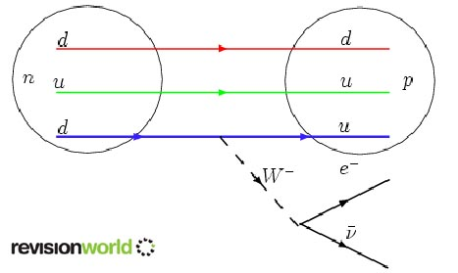**Hadrons**: Not fundamental. Affected by strong interaction. **Baryons** (neutrons and protons). **Mesons** (pions). Mesons consist of a quark-antiquark doublet whereas baryons consist of a triplet.

**Baryons:** particles have a baryon number of 1, anti-particles have a baryon number of -1

**Mesons:** particles and anti-particles have a baryon number of 0

|  |  |  |
| --- | --- | --- |
| **Quark** | **Charge** | **Baryon** |
| u | $$+\frac{2}{3}e$$ | $$\frac{1}{3}$$ |
| d | $$-\frac{1}{3}e$$ | $$\frac{1}{3}$$ |

**Equations:** Charge, baryon number and lepton number are all conserved in interactions.

**Gauge bosons**: exchange particles which mediate the force between the fundamental particles involved in the four fundamental forces

**In research**: Electrons, unlike protons and neutrons are not affected but the strong nuclear force and so may be used to bombard nuclei.

**Beta minus Decay:** result of the weak nuclear interaction

${}_{0}^{1}n + → {}_{1}^{1}p + {}_{-1}^{0}{e^{-}} + {}_{0}^{0}{\overline{v_{e}}}$ $udd + → uud + {}_{-1}^{0}{e^{-}} + {}_{0}^{0}{\overline{v_{e}}}$ $d → u +W^{-} followed by W^{-} → e^{-} + \overline{v_{e}}$

**Quark Models:** p uud, n udd, $π^{0} u\overline{u}$, $π^{+} u\overline{d}$, $π^{-} d\overline{u}$, $\overline{π^{0}} u\overline{u}$

Anti-quarks have oppposite charge and baryon number